

*GUVI PROJECT*

*GU’S JOY BOY CREW*

*EMPLOYEE MANAGEMENT SYSTEM*

-CREW LEADER AAYUSH UPADHYAY

[Parajuliaayush23@gmail.com](mailto:Parajuliaayush23@gmail.com)

24SCSE1410026

-MEMBERS 1. MANISH KUMAR

. [sunnysah284@gmail.com](mailto:sunnysah284@gmail.com)

.24SCSE1010886

2. Sunny Kumar

. [sr388567@gmail.com](mailto:sr388567@gmail.com)

. 24SCSE1010243

3. Lijom Ngomdir

. [lijom360@gmail.com](mailto:lijom360@gmail.com)

-SUBJECT JAVA PROGRAMMING

(E1UA307C)

-FACALTY MR. K. RAJKANNAN

COURSE CSE AI

SECTION 33

|  |  |  |
| --- | --- | --- |
| **S. No.** | **Topic** | **Page No.** |
| 1 | Declaration | 2 |
| 2 | Certificate | 3 |
| 3 | Acknowledgement | 4 |
| 4 | Abstract | 6 |
| 5 | Chapter-1: Introduction | 6 |
| 6 | Chapter-2: Objective | 6 |
| 7 | Chapter-3: Methodology | 7 |
| 8 | Chapter-4: Feasibility Study | 8 |
| 9 | Chapter-5: Implementation and Results | 9 |
| 10 | Chapter-6: Testing | 12 |
| 11 | Chapter-7: Conclusion | 13 |
| 12 | Chapter-8: Future Scope | 13 |
| 13 | Chapter-9: References | 14 |

**TABLE OF CONTENTS**

**TABLE OF FIGURES**

|  |  |  |
| --- | --- | --- |
| **Figure No.** | **Caption of the Figure** | **Page No.** |
| 1 | Login frame | 9 |
| 2 | Main Dashboard | 9 |
| 3 | Add employee | 10 |
| 4 | Remove employee | 10 |
| 5 | View and Update employee | 11 |

## Abstract

*Human resource difficulties face all businesses, large and small. Because every organization has different staff management needs, we create custom employee management solutions that are tailored to your needs. This is intended to aid strategic planning and guarantee that your firm has the appropriate degree of human resources to meet your long-term objectives. This approach will help you to better manage your resources in the long run.*

## Introduction

Everything has been digitised in our age of ever-increasing technology. The human workforce has grown as a result of the abundance of job options. As a result, a system that can handle the data of such a vast number of people in a company is required. Because of its user-friendly design, this project makes the process of keeping records easier. The "EMPLOYEE MANAGEMENT SYSTEM" was created to address the issues that plagued the previous manual system. This programme is designed to eliminate, and in some cases, decrease, the problems that the current system has.

To eliminate data entry mistakes, the software is kept as simple as possible. When inputting incorrect data, it also displays an error notice. The user doesn’t require any formal expertise to operate this system. The admin will be able to add new employees to this project. Employee data may also be seen and printed by the administrator. Admins can also remove an employee and change their details.

## Objective

The objective of this work is to give a complete approach to personnel information management. This will be accomplished by developing and deploying an HR management system that will result in a significant shift in the way employee data is managed.

This system's objectives include the following:

1. Design of an HR management system to meet needs such as adding and deleting employees, viewing and printing employee data, and updating employee information.
2. Employee data is stored in a well-designed database.
3. An easy-to-use interface that will let user interact with the system.

## Methodology

The methodology to complete this project is as follows:

1. I explored net beans, concepts of swings and applets.
2. For further and a deeper understanding, I even referred to some articles, books, journals, websites and news articles.

Below are the important concepts on which the work has been done and with the support of these I was able to work on my project.

**NET BEANS-** NetBeans is a Java-based integrated development environment (IDE). NetBeans enables the creation of applications using a set of modular software components known as modules. NetBeans is compatible with Windows, Mac OS X, Linux, and Solaris. It also allows other programming languages to be extended. In addition to Java programming, Third-party developers can expand NetBeans-based applications, including the NetBeans IDE.

**JAVA-** High-level, Object-Oriented programming language which help programmers to run their applications efficiently. JAVA is the programming language which comes into our minds when we talk about android application. By using JAVA as a programming language, programmer can develop any type of android application easily. JAVA also provides many libraries which also helps in making efficient android application. Swing is a Java GUI widget toolkit. It's part of Oracle's Java Foundation Classes (JFC), which provides an API for creating graphical-user- interfaces for Java programmes.

**SWING-** Swing is a Java GUI widget toolkit. It's part of Oracle's Java Foundation Classes (JFC), which provides an API for creating-graphical-user-interfaces for Java programmes. Swing was created to give a more advanced collection of graphical user interface components than the previous Abstract Window Toolkit (AWT). Swing offers a pluggable look and feel that allows applications to have alook &feel that is unconnected to the underlying platform, as well as a look & feel that emulates the look & feel of numerous platforms.

**SQL-** SQL (Structured Query Language) is a computer language that is used to manage data in a relational database management system (RDBMS) or for stream processing in a relational data stream management system (RDSMS). It's especially beneficial for dealing with structured data, or data that has relationships between entities and variables.

## Methodology

The methodology to complete this project is as follows:

1. I explored net beans, concepts of swings and applets.
2. For further and a deeper understanding, I even referred to some articles, books, journals, websites and news articles.

Below are the important concepts on which the work has been done and with the support of these I was able to work on my project.

**NET BEANS-** NetBeans is a Java-based integrated development environment (IDE). NetBeans enables the creation of applications using a set of modular software components known as modules. NetBeans is compatible with Windows, Mac OS X, Linux, and Solaris. It also allows other programming languages to be extended. In addition to Java programming, Third-party developers can expand NetBeans-based applications, including the NetBeans IDE.

**JAVA-** High-level, Object-Oriented programming language which help programmers to run their applications efficiently. JAVA is the programming language which comes into our minds when we talk about android application. By using JAVA as a programming language, programmer can develop any type of android application easily. JAVA also provides many libraries which also helps in making efficient android application. Swing is a Java GUI widget toolkit. It's part of Oracle's Java Foundation Classes (JFC), which provides an API for creating graphical-user- interfaces for Java programmes.

**SWING-** Swing is a Java GUI widget toolkit. It's part of Oracle's Java Foundation Classes (JFC), which provides an API for creating-graphical-user-interfaces for Java programmes. Swing was created to give a more advanced collection of graphical user interface components than the previous Abstract Window Toolkit (AWT). Swing offers a pluggable look and feel that allows applications to have alook &feel that is unconnected to the underlying platform, as well as a look & feel that emulates the look & feel of numerous platforms.

**SQL-** SQL (Structured Query Language) is a computer language that is used to manage data in a relational database management system (RDBMS) or for stream processing in a relational data stream management system (RDSMS). It's especially beneficial for dealing with structured data, or data that has relationships between entities and variables.

## Feasibility Study

In order to do a feasibility study, we must consider the following:

1. **Technical Feasibility**

The availability of hardware & Software necessary for the creation of the system, as-well- as the compatibility and maturity of the technology planned to be used, and the availability of the requisite technical staff to create the system, are all factors to consider.

1. **Operational Feasibility**

Problems that may develop during operations are the focus of operation feasibility. There are two parts to this problem to consider:

* + What are the chances that the solution provided will not be used or will not work?
  + What is the inclination of-the management and end users towards the solution?

1. **Economic Feasibility**

The concept of economic feasibility is determining whether or not the potential benefit of fixing difficulties is worth while. Because member needs &alternative solutions haven’t been specified at this point, it is difficult to estimate the cost at this level.

## IMPLEMENTATION AND RESULT

Following are the screens of the Employee Management System where you can see all the features of this system in use and you can also see the GUI of the system:

1. A screenshot of a login form

   Description automatically generated**Login frame** – This is the login frame of this system where user have to enter the required credentials to have access for the main dashboard.

Fig. 1

1. **Main Dashboard** – After login in, user is directed to the main dashboard of this system where user can perform various operations like adding an employee, deleting an employee

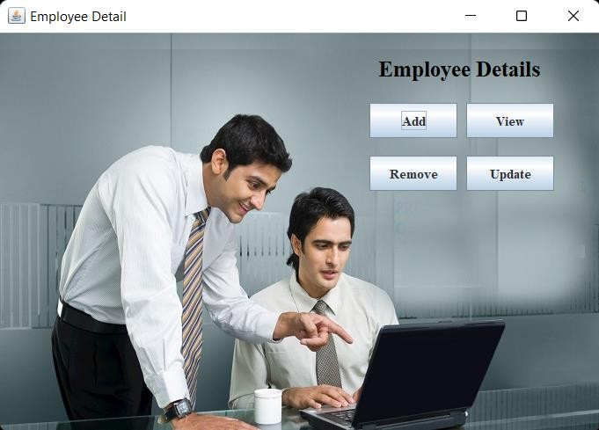

Fig. 2

1. **Add employee** – Here user have to enter all the required credentials to add a new employee to the system.

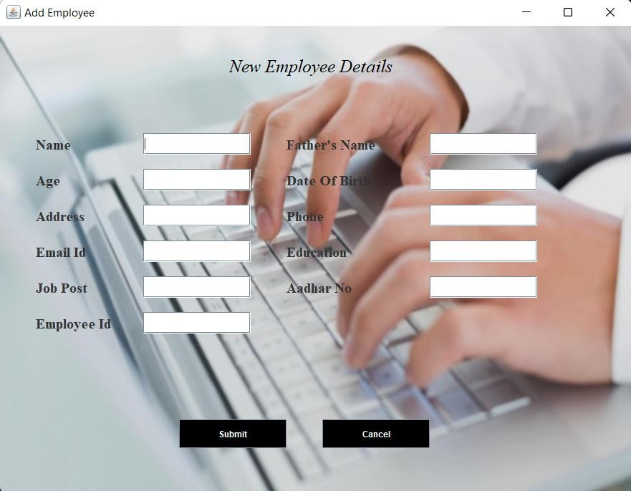

Fig. 3

1. **Remove employee** – User has to enter the employee id in order to delete his information from the system.

Fig. 4

1. **View and update employee** – In order to view and update employee information, the user have to enter employee ID.